Introduction
A strategies workshop for TOWN NAME was held at the Location on Date. The meeting was a combination presentation and open house. First, the attendees learned about the project process, the toolkit, vision framework, and strategies. The meeting transitioned to an open house where attendees prioritized the strategies on boards and had the opportunity to have one-on-one discussions with members of the project team and steering committee. Attendees also indicated locations for the strategies on a large map. XX people signed in and an estimated XX people were in attendance.
Feedback
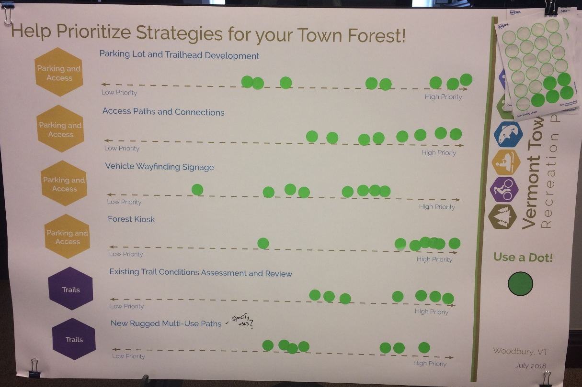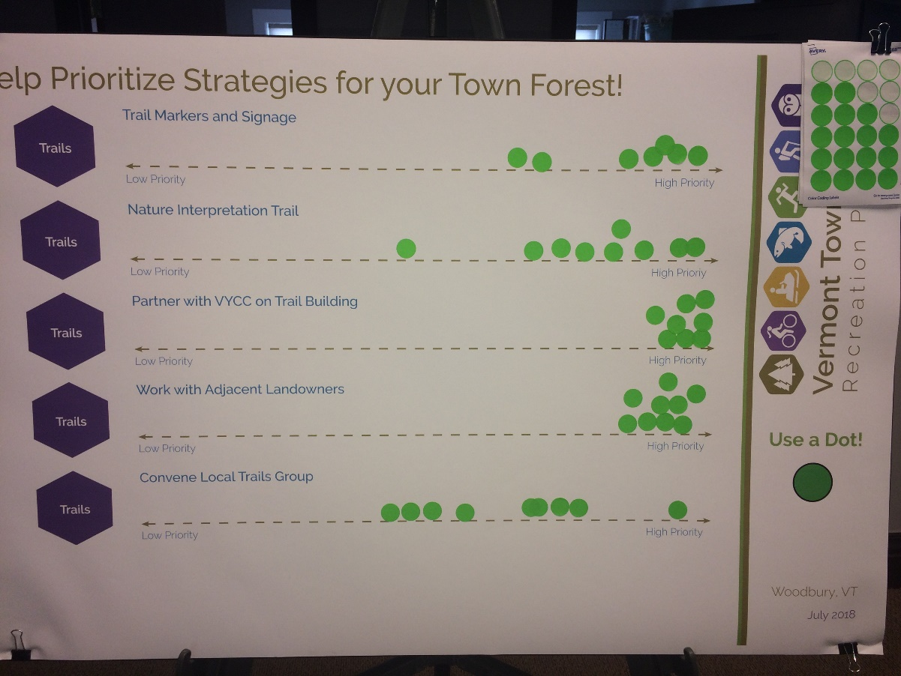
Paste image of priority board from workshop

Paste image of priority board from workshop

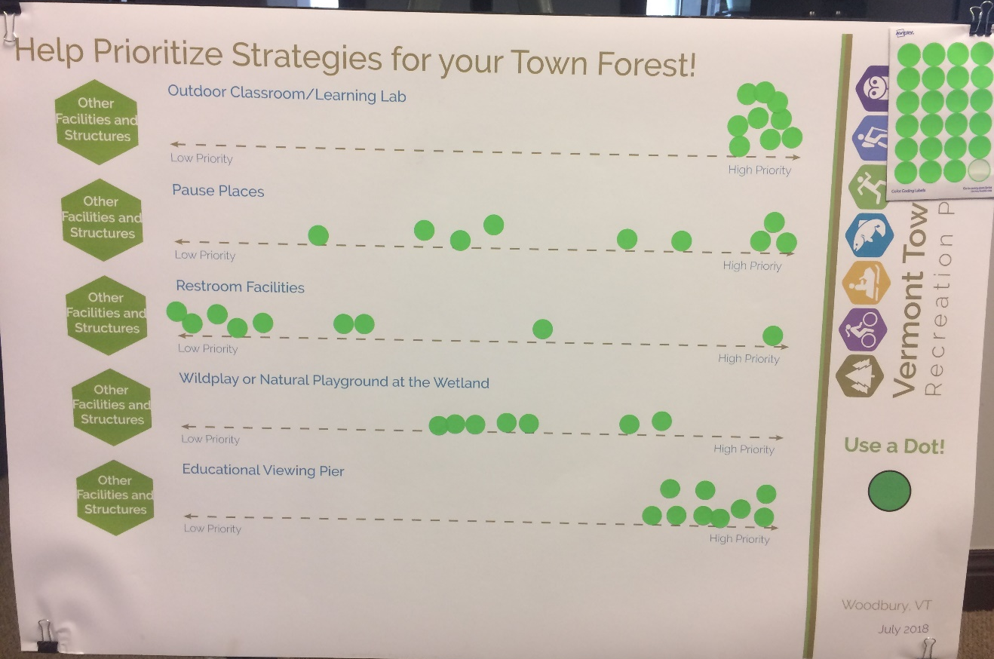
Paste image of priority board from workshop

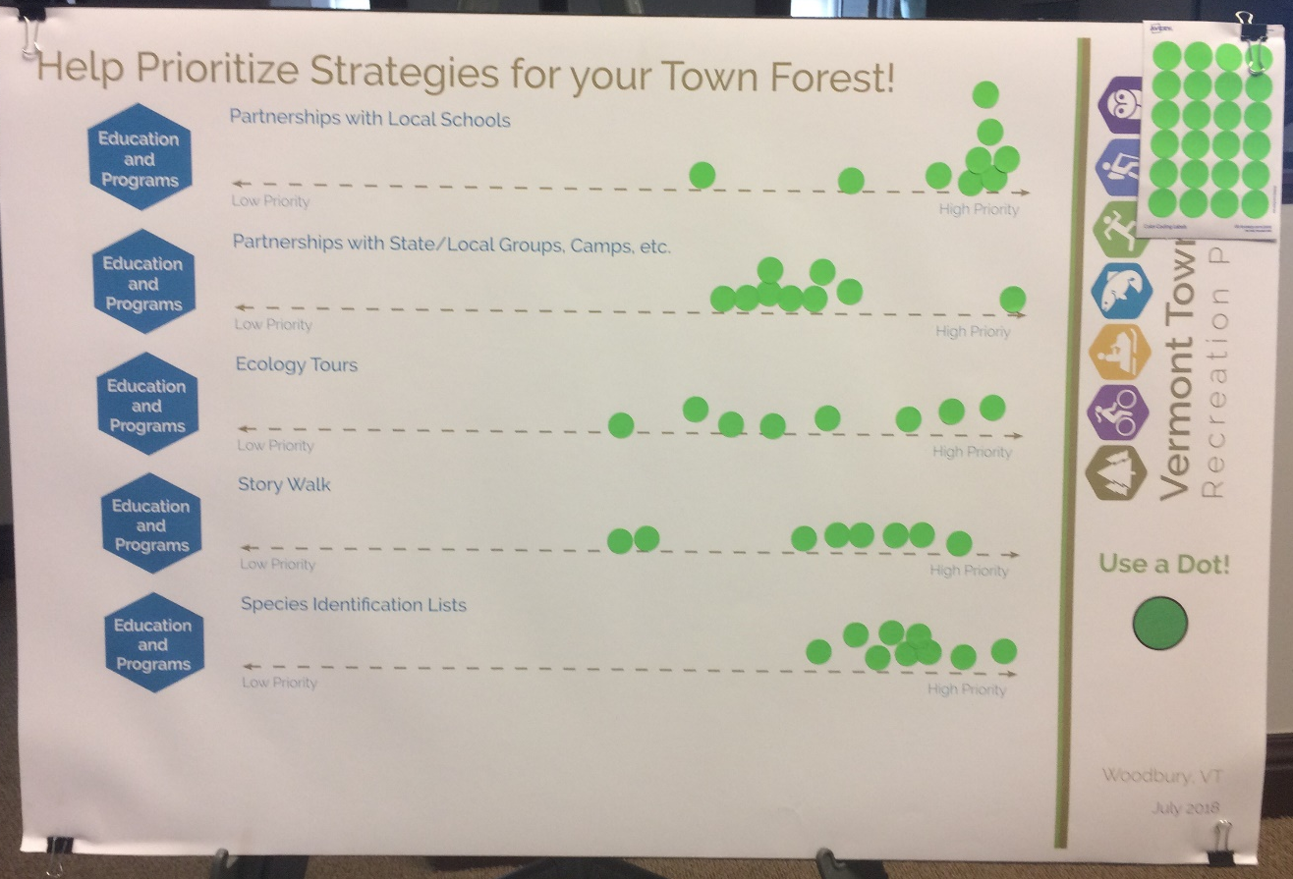
Paste image of priority board from workshop

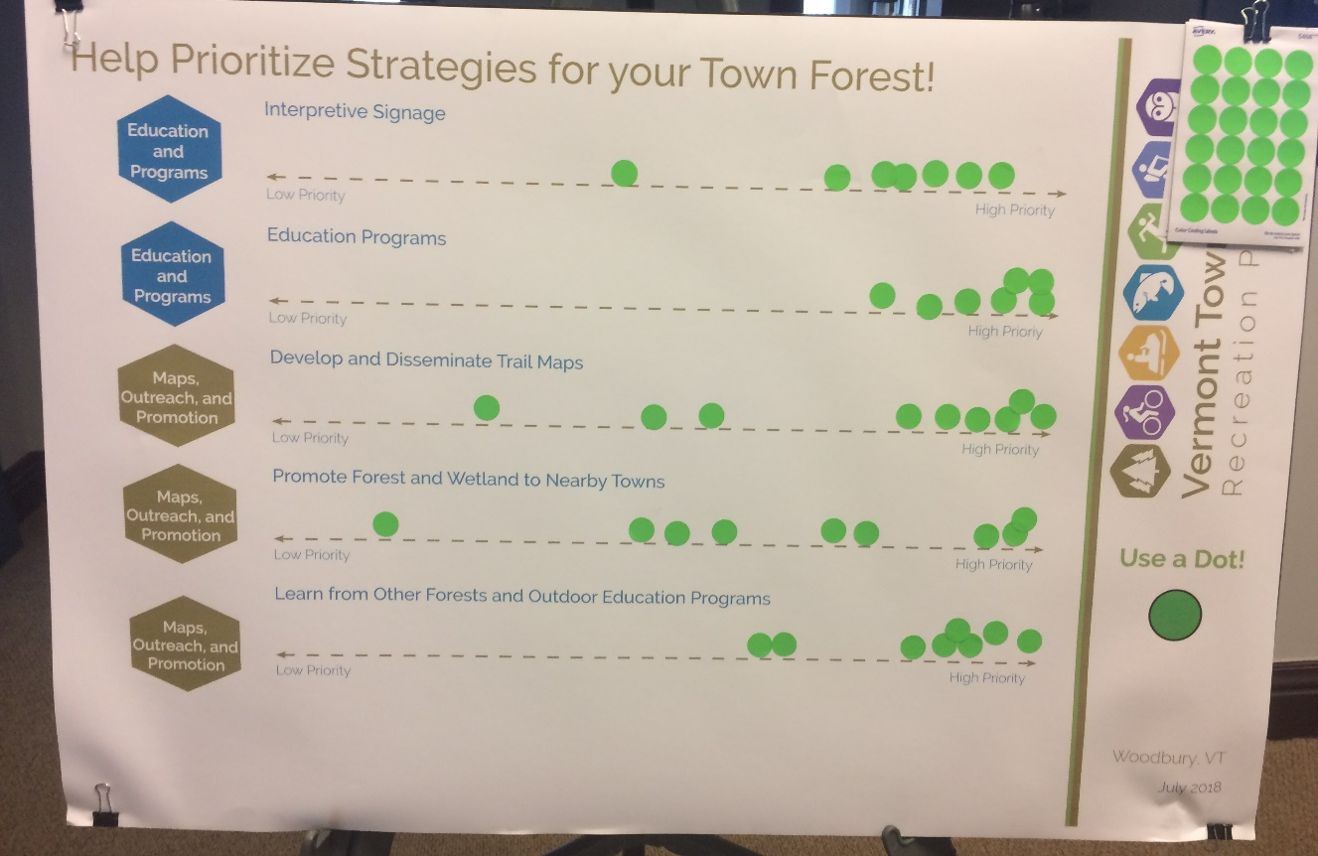
Paste image of priority board from workshop

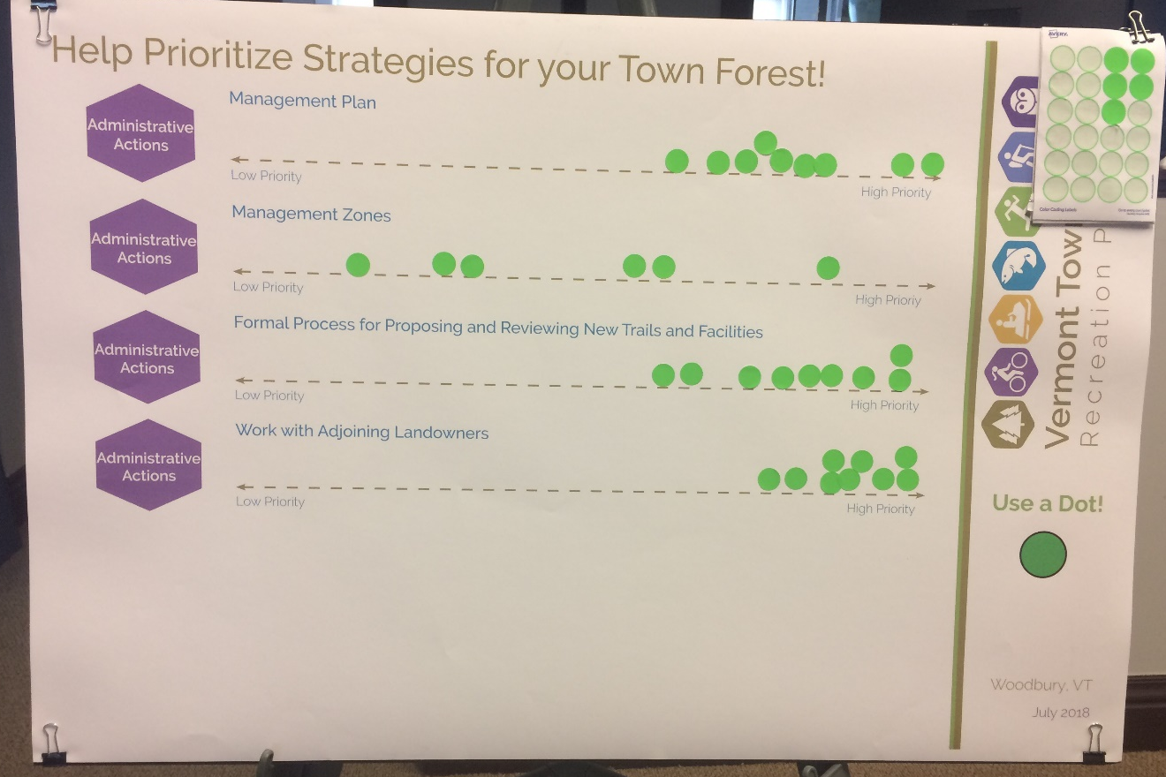
Paste image of priority board from workshop

Floormaps
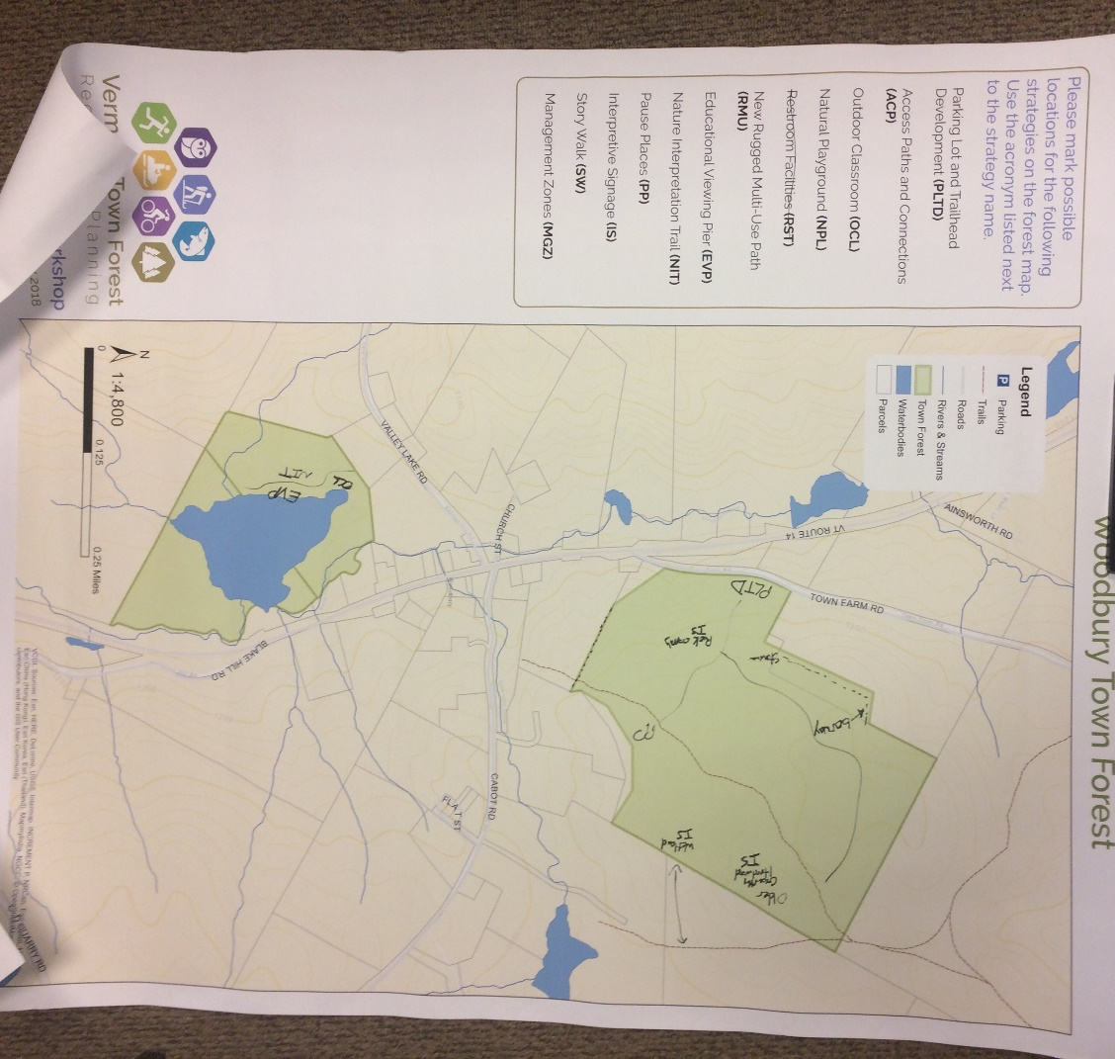
Paste image of floormap from workshop

