Vision Framework Guidance & Worksheet
To effectively plan for YOUR TOWN FOREST we must distill the community’s ideas about the forest into a vision framework that may be called upon to guide this effort as well as future decision making for the forest. This worksheet is meant to provide guidance and an established structure for you and your fellow committee members to work together to craft a vision framework for your town forest, and to review the Draft Strategies to be presented to and prioritized by the public at the next community workshop.

What is a Vision Framework?
A vision framework is a critically important tool that informs the goals and direction of the town forest recreation plan. The vision framework should encompass all forest uses—not just recreation—so we know how recreation should fit in with the community’s overall intent for the forest. The vision framework should be directional, descriptive, and aspirational. It should communicate what the community believes are the ideal conditions for the forest—how things would look if all opportunities and issues were perfectly addressed.
A vision framework includes:
- A discussion of the management balance in the forest; and
- A list of key attributes that describe the community’s desired character for the forest
The vision framework should be broad enough to encompass a variety of local perspectives and should be inspiring and uplifting to everyone involved in your effort. Unlike a simple one or two sentence vision statement, a vision framework allows for more complexity to be communicated and can better illuminate the community’s desired character for the forest—which is often multi-faceted.
The management balance discussion and list of key attributes should work together to communicate the community’s overarching aspirations for the forest. Both aspects of the vision framework should be in alignment with each other, but they do not need to repeat each other. The management balance should describe the community’s management priorities for the forest, while key attributes should be a list of words or short phrases that expand upon the management balance and further describe the community’s desired future character for the forest. They should work together and support each other to communicate the multi-faceted values of the community.

What do I need to do?
We ask that you complete this worksheet to help you think about the community’s vision for the town forest. The worksheet asks you to combine your understanding of the town forest with the community’s input thus far to develop a vision framework. The worksheet also asks you to list of issues, needs, and ideas identified throughout the visioning process. While these are not necessarily part of the “vision” for the town forest, they—along with the vision framework—inform the development of the strategies. Finally, you will draft strategies for the town forest to explore with the community. A companion tool for this worksheet is the Vermont Town Forest Natural Resource Guide (in Natural Resource Pod) which should be used to help guide decision-making. This worksheet is the committee’s opportunity to establish a vision framework and strategies to present to the community at the next workshop for their review and prioritization of strategies.
As steering committee members, you are both interested stakeholders with valuable personal perspectives AND stewards of public land with a strong connection to the community you serve. We ask that you share both your personal thoughts AND your sense of the broader community sentiment—drawing from visioning process results and from present and past conversations in your town. If you feel there might be a divergence between the two, we just ask you share that too in your responses.
You may choose to have committee members complete the worksheets at home on their own and then have everyone share their answers in your committee meeting. You may also choose to go through the worksheet as one group and fill it in that way.

Management Balance
Town Forests can be managed to provide a wide range of activities and community values. Four common use areas include Recreation; Education & Land Use Demonstration Projects; Natural Resources & Habitat; and Timber & Forest Products. While most publicly accessible forests provide some measure of all four types of uses, they tend to “lean” in one management direction or another.
To understand the desired balance for YOUR TOWN FOREST, you asked survey and workshop participants “Where do you think the management focus SHOULD fall for the Town Forest in your community? Should it lean towards Recreation, Education, Timber & Forest Products, or Natural Resources & Habitat?”
Through these interactions, the YOUR TOWN community expressed … Please describe the results of the management balance exercise from the survey and visioning workshop. This answer can come from the survey and visioning results document.
Below you will find the results of the workshop and survey responses pertaining to the management balance of your town forest. Now, as the committee, please review the management balance data, consider how it might inform your vision framework, and answer the questions below.

Public Workshop
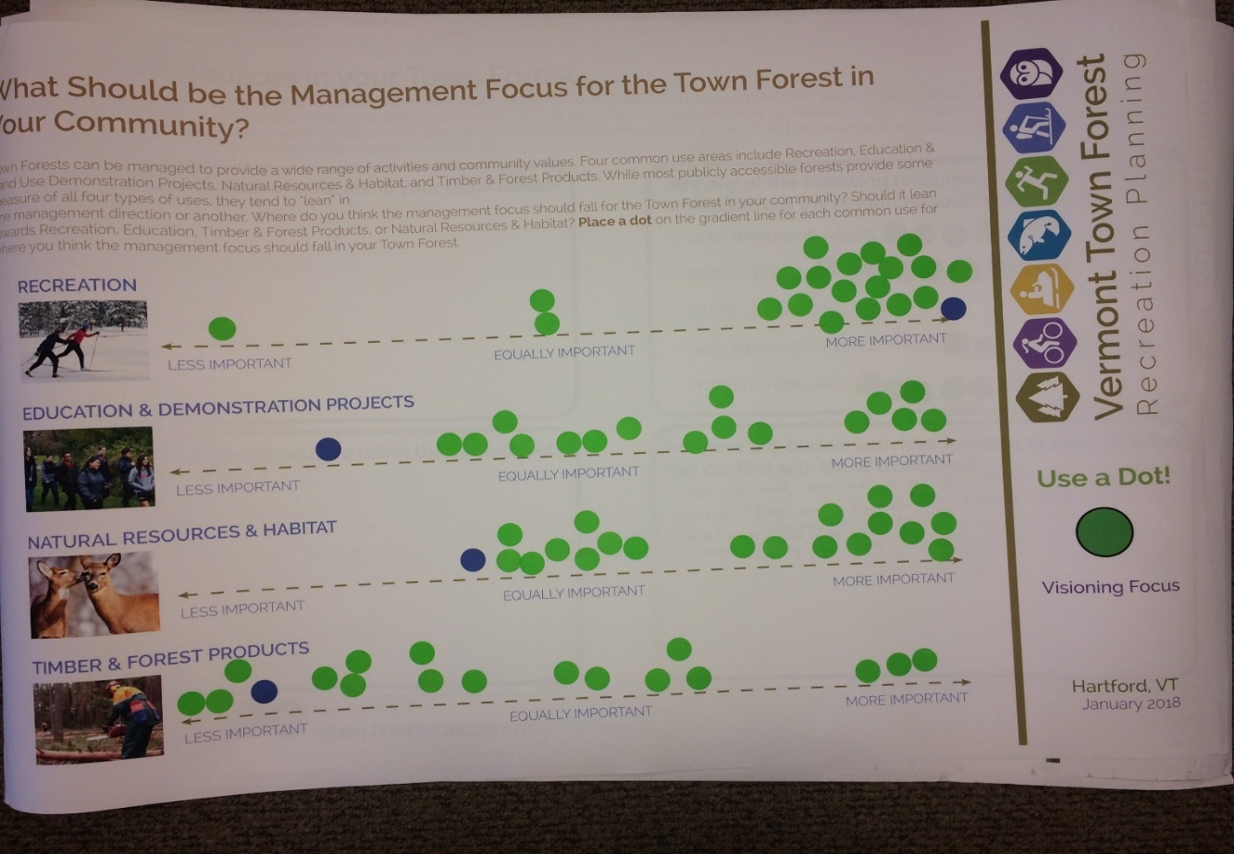
PASTE THE PHOTO OF YOUR BOARD FROM THE MEETING

Survey Results
Less Important
Equally Important
More Important
PASTE SURVEY RESULTS CHART
Do you feel the management balance described above aligns with the committee’s thinking? (Circle One) Yes No
If no, why not? _______________________________________________________ __________________________________________________________________________________________________________________________________________________________________________
Do you feel the management balance feedback received is representative of the broader community sentiment towards the town forest? Are there perspectives that may not be reflected here?________________________________________________________________________________ _______________________________________________________________________________________________________________________________________________________________________________________________________________________________________________________________
Other thoughts on management balance? ________________________________________________ _________________________________________________________________________________________________________________________________________________________________________________________________________________________________________________________________________________________________________________________________________________________________________________________________________________________________________

Survey and Workshop Visioning Input
Survey respondents and workshop participants were asked “what word or phrase best describes your EXISTING experience and your FUTURE DESIRED experience in your town forest?” Responses were aggregated and used to form the word clouds below. The size of the words in the word clouds corresponds to the number of times that word was used in the responses. Please review the word clouds and the verbatim responses for each question to inform your thinking about the vision framework.

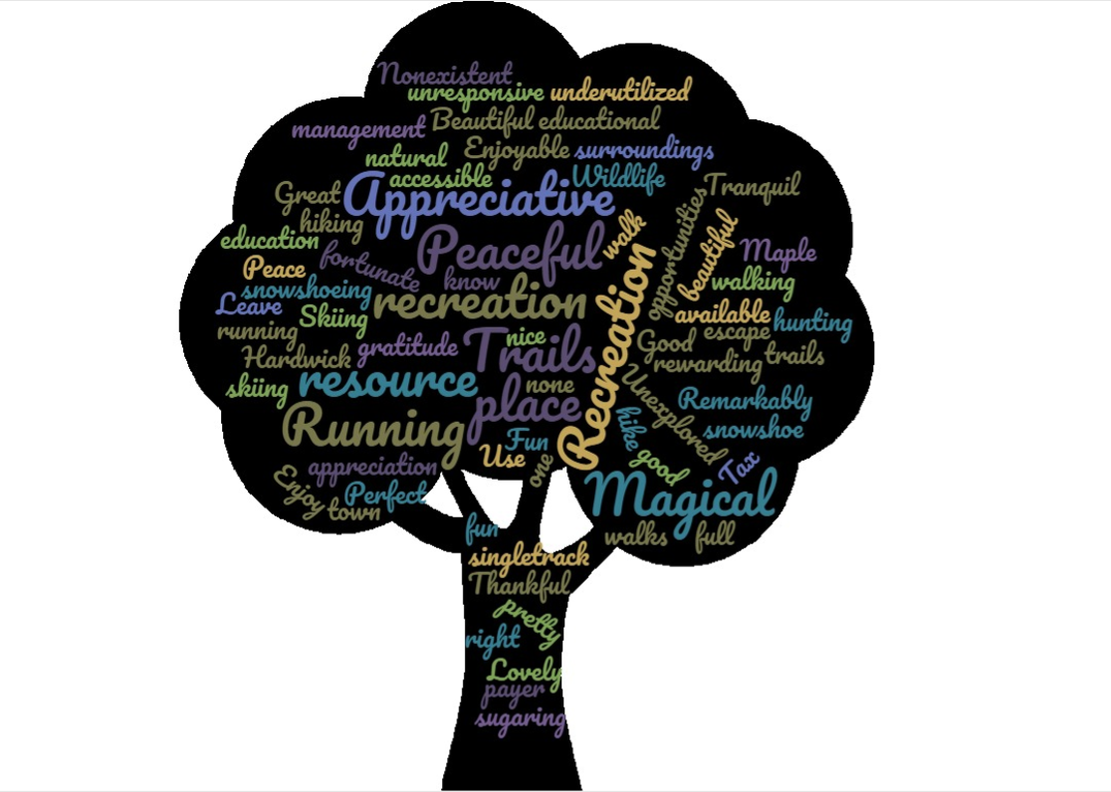
Q1: What word or phrase best describes your EXISTING experience in your Town Forest?
PASTE WORD CLOUD FROM SURVEY AND VISIONING RESULTS DOC

Verbatim Responses: Paste verbatim responses from online survey (if conducted)

Q2: What word or phrase best describes your FUTURE DESIRED experience in your Town Forest?
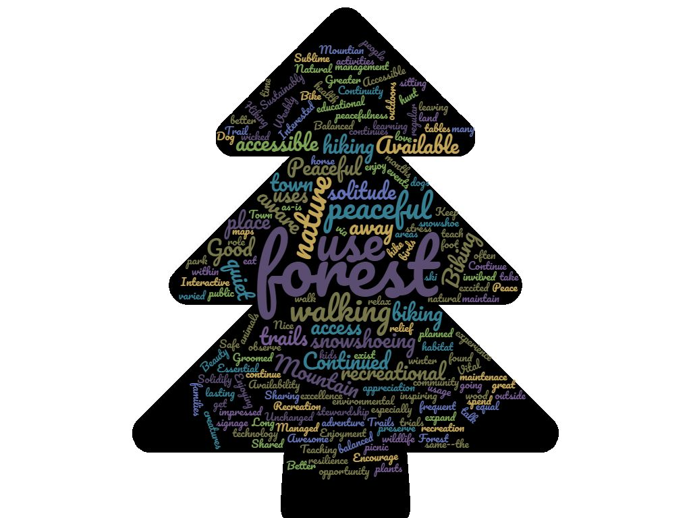
PASTE WORD CLOUD FROM SURVEY AND VISIONING RESULTS DOC
Verbatim Responses: Paste verbatim responses from online survey (if conducted)

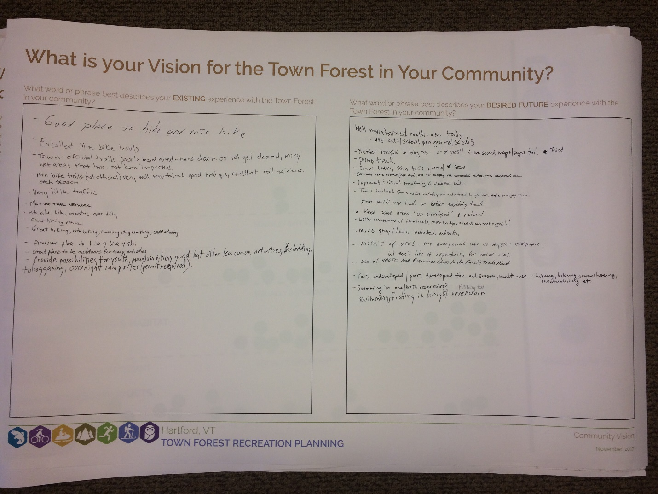
PASTE VISIONING BOARD FROM WORKSHOP

Key Attributes
The following is a master list of key attributes from the ten pilot communities in the town forest recreation planning project. This list was based on public and committee input received throughout the visioning process, as well as the community’s demographics, community profile, forest information, current management plans, surveys, conservation easements. Please use these key attributes as a starting point for key attributes for your town forest. You may repurpose or retool some of the attributes from other communities or come up with your own.
Remember, key attributes should be words or short phrases that communicate what the community believes are the ideal conditions for the forest—how things would look if all opportunities and issues were perfectly addressed, which may be the same or different from how things look today.
- Year-round recreation (snowshoeing, biking, hiking)
- Natural, peaceful and quiet
- Sustainable and well-maintained trail system
- Protection of bird and wildlife habitat
- Protection of vernal pools, wetlands, and other water resources
- Remarkable biodiversity
- Protection of forest integrity
- Preserve and interpret historical and cultural resources
- A piece of a larger connected forest block
- Connectivity with surrounding trail systems
- Maintain healthy balance between stewardship and human uses
- A forest for the entire community
- Low key and low intensity use
- Sustainable management for multiple uses
- Multi-dimensional (haying, sugaring, habitat, conservation, recreation, etc.)
- Multi-generational
- Educational and recreational forest for school children
- Easily accessible for both the community and visitors
- Community engaged in the future and maintenance of the forest
- Hunting opportunities
- Quieter, uncrowded hiking options
- Gentle, easy walking trails
- A variety of recreational assets and opportunities
- Generating economic activity in the town
- Local community gathering place
- Parking area to accommodate residents, visitors, and school buses
- Healthy old-growth forest
- Utilized for scientific studies and monitoring programs
- Events that bring the community together
- Many non-motorized recreation opportunities
- Solitude, rest, and rejuvenation
- Accessible and encouraging of community use
- Place for children and the community to be outside and experience nature
- Opportunities for learning about stewardship, history, and the forest
- Responsible, non-commercial timber harvest that maintains healthy forest and recreational opportunities
- Successful partnership and collaboration amongst all trail users
- Balance potentially competing uses: hunting, mountain biking, hiking, and agriculture
- Inclusive of a variety of users and community perspectives
- Well-known community asset
- Showcasing unique features of the forest
- Educational forest for local school children and higher education research
- Beautiful vistas
- Place to appreciate the natural world
- Encouraging passersby to stop in town
- Easy to follow maps and trail signage system
- Clear and frequent signage and well-marked trails
- Partnerships for additional outdoor opportunities for residents
Please circle the key attributes you see for your forest. Which of the attributes are most important to you?___________________________________________________________________________________________________________________________________________________________________________________________________________________________________________________________
Are there additional important attributes that you envision for your forest ?_____________________ _______________________________________________________________________________________________________________________________________________________________________________________________________________________________________________________________

Issues, Needs, and Ideas
While not necessarily part of the “vision” for the forest, the identification of issues, needs and ideas is a critical component for understanding the future direction for the forest and crafting strategies to move in that direction. Similar to the key attributes, the identification of issues, needs, and ideas should draw upon all the available sources of information about the forest and the community. Below is a list of a few common issues and needs for town forests. In general, these issues tend to be very unique to each town forest and we ask that you write in additional issues and needs around your forest.
They are as follows:
- Unsustainable trail system - poor drainage, ineffective trail layout/design for desired uses, trails in ecologically sensitive areas
- Forest is underutilized and community is largely unaware of the forest
- No program in place for trail maintenance
- Forest lacks a destination or gathering place
- Need for collaborative community dialogue around trails
Which of the issues, needs, and ideas above is also an issue, need, or idea in your town forest? _____________________________________________________________________________________ ___________________________________________________________________________________________________________________________________________________________________________________________________________________________________________________________________________________________________________________________________________________________________________________________________________________________________________________________________________________________________________________________________________________________________________________________________________________
What additional issues, needs, or ideas are associated with your town forest? __________________ _____________________________________________________________________________________________________________________________________________________________________________________________________________________________________________________________________________________________________________________________________________________________________________________________________________________________________________________________________________________________________________________________________________________________________________________________________________________________________________________________________________________________________________________________________________________________________________________________

Strategies
Based on the key attributes and issues, needs, and ideas, for the forest, please select strategies to help your forest achieve the key attributes or resolve the issues, needs, and ideas. The recreational improvements strategy database in the project toolkit includes all the strategies considered by the 10 pilot communities, many of which may apply to your town. You may also decide to generate your own strategies. Please generate your potential strategies and list them in the table below. Remember, at this point you are trying to identify ALL the strategies that might help you achieve the community’s vision for the forest—think of it as “a menu” of things you may do in the forest. This large list of strategies will be presented to community at the “Draft Strategies” workshop where community members will help select and prioritize the strategies that are best aligned with the community’s vision for the forest—they will “order off the menu”!
Strategy or Action | Description | Relative Cost  ($-$$-$$$-$$$$) | Toolkit & Support Resources
1. Parking & Access
2. Trails
3. Other Facilities and Structures
4. Education & Programs
5. Events
6. Maps, Outreach, & Promotion
7. Administrative Actions

Are there additional important strategies for your forest that are not included in the database?____________________________________________________________________________ _______________________________________________________________________________________________________________________________________________________________________________________________________________________________________________________________
Any other final thoughts? _______________________________________________________________ ______________________________________________________________________________________________________________________________________________________________________________________________________________________________________________________________________________________________________________________________________________________________________________________________________________________________________________________________________________________________________________________________________________________________________________________________________________________________________________________________________________________________________________________________________________________________________________________________________________________________________________________________________________________________________________________________________________________________________________________________________________________________________________________________________________________________________________________________________________________________________________________________________________________________________________________________________________________________________________________________________________________________________________________________________________________________________________________________________________________________________________________________________________________________________________________________________________________________________________________________________________________________________________________________________________________________________________________________________________________________________________________________________________________________________________________________________________

